Task 1 — Repository Initiation
1. Create a new folder named intern-portfolio.
2. Initialize it as a Git repository.
3. Configure your Git username and email (if not already set).
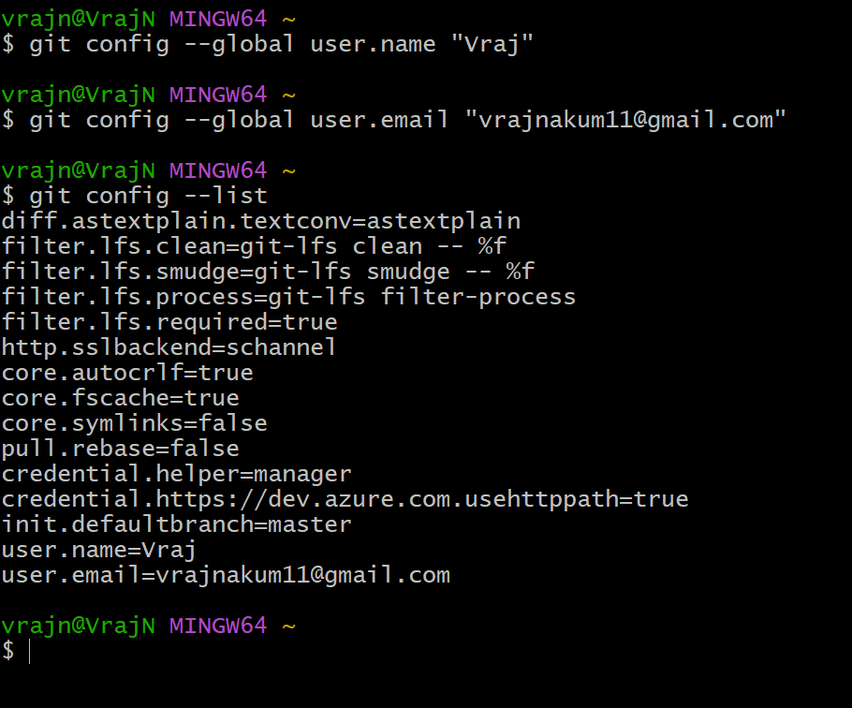
4. Verify that initialization was successful.

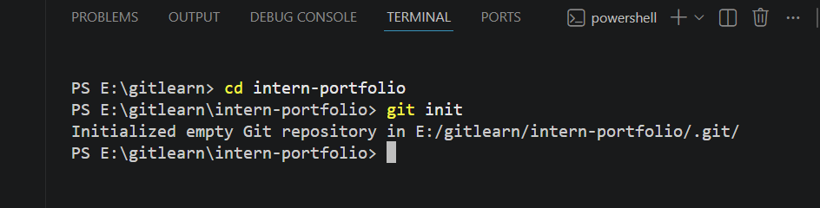

Task 2 — Staging & Committing
1. Create three files inside the folder: index.html (a basic HTML page with your name), about.txt (2–3 lines about
yourself), and notes.md (any notes).
2. Check the status of your repository.
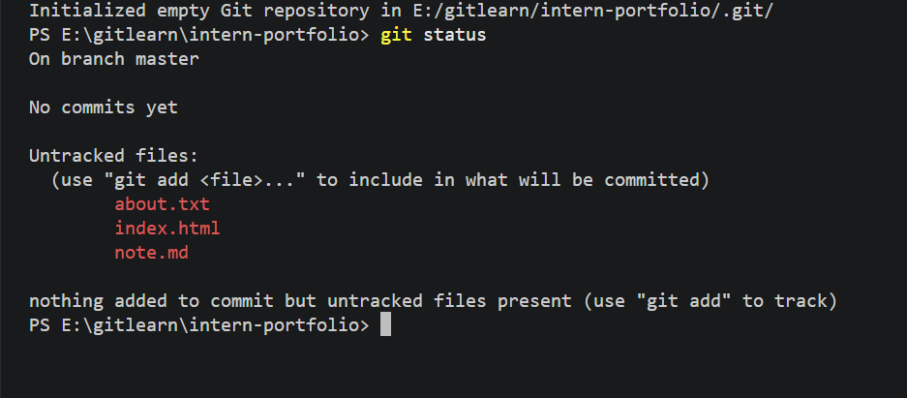
3. Stage index.html and about.txt, then commit them with a meaningful commit message.
4. Stage and commit notes.md separately with another meaningful commit message.
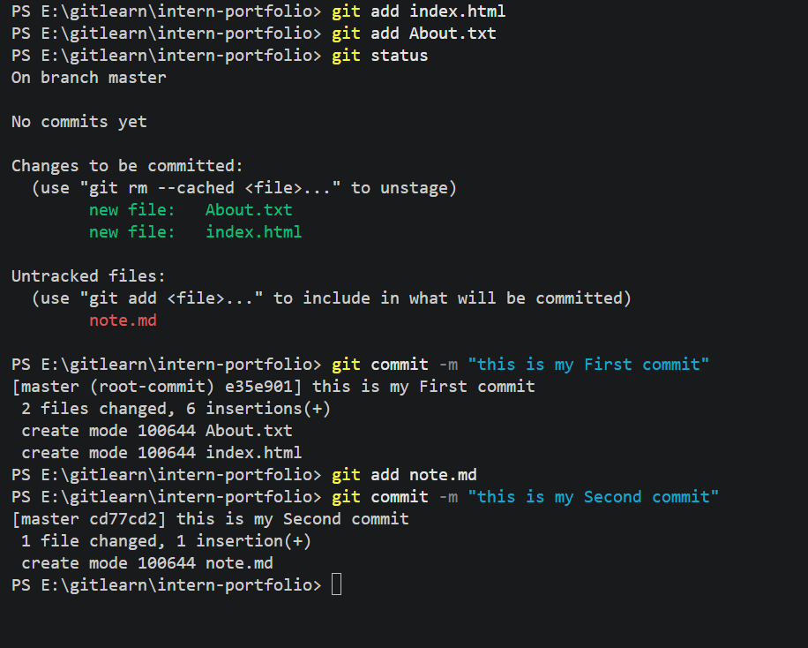
5. View your commit history.

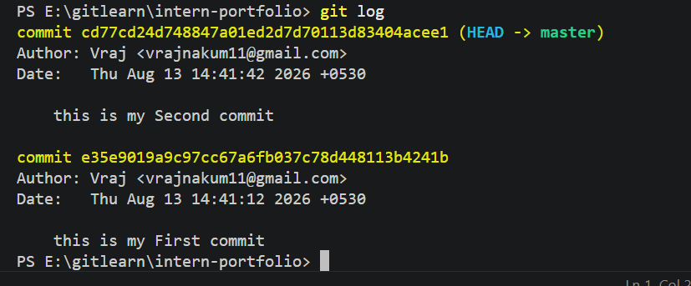

Task 3 — Remote Repository Setup
1. Create a new public repository on GitHub named intern-portfolio.
2. Connect your local repository to the GitHub repository.
3. Push your local main branch to GitHub.
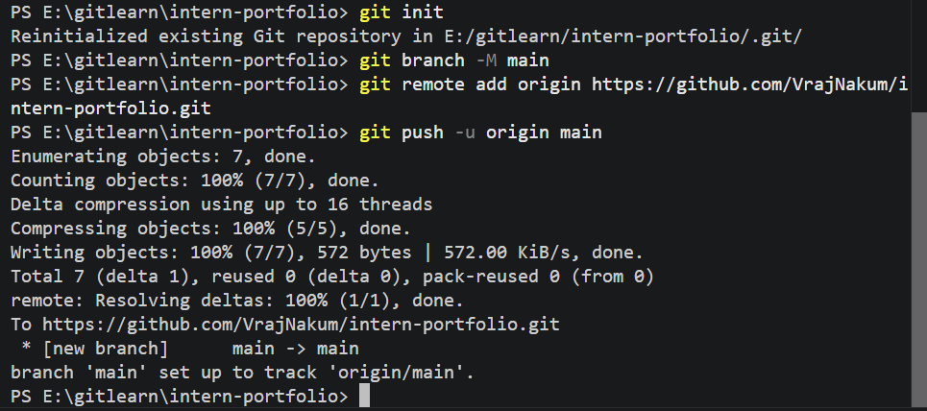
4. Confirm on GitHub.com that all your files and commit history are visible.
git add README.md
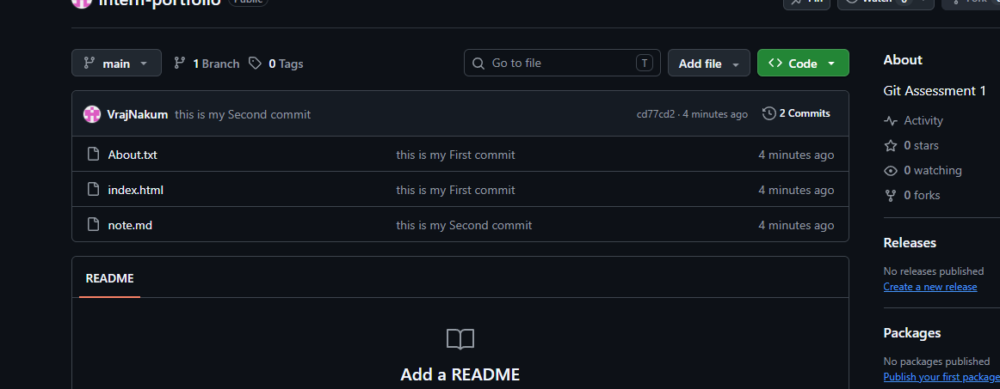

Task 4 — Branching & Merging
- Create a new branch called feature-update and switch to it.
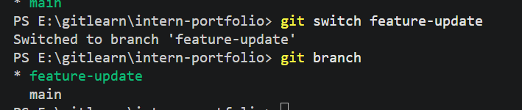
- On this branch, add a new section to index.html (for example, a “Skills” section) and edit about.txt.
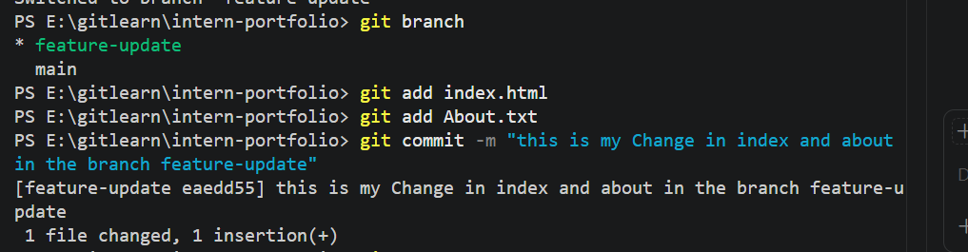
3. Stage and commit these changes on the feature-update branch.
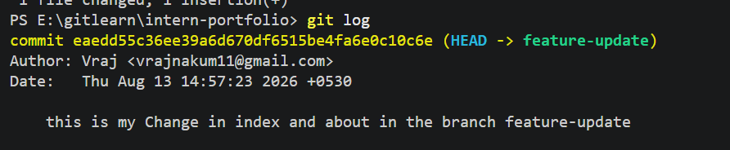

- Push the feature-update branch to GitHub.

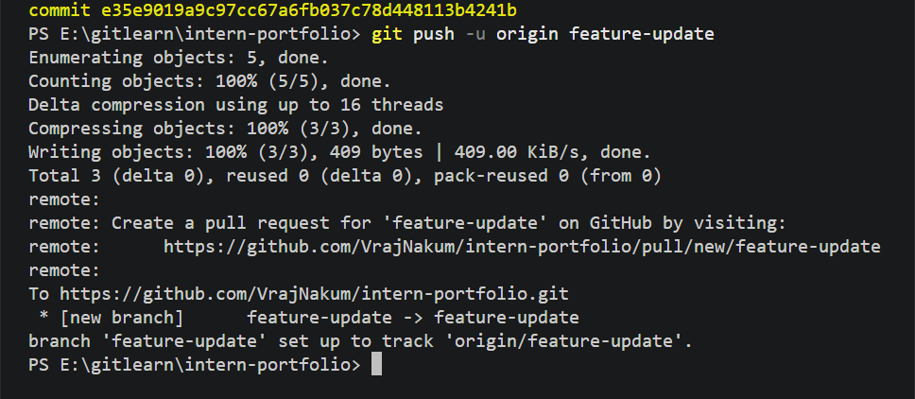
- Switch back to the main branch locally and confirm your changes are not present there.

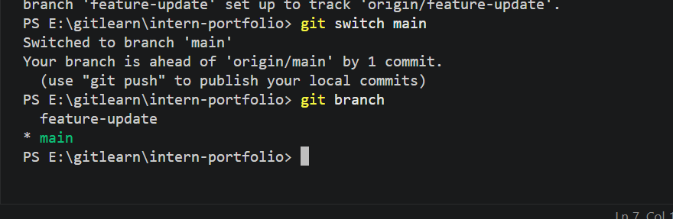
- Merge the feature-update branch into main locally.
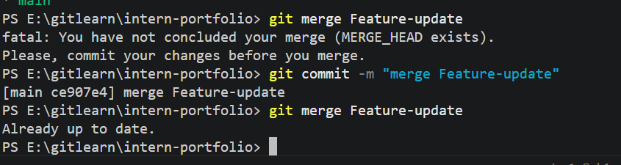
- Push the updated main branch to GitHub.

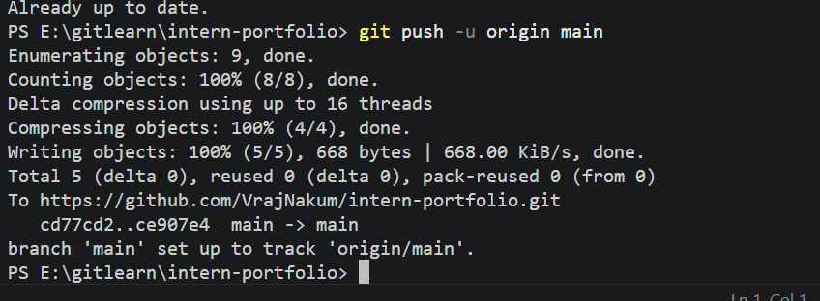

Task 5 — Pull Request Workflow
1. Create another branch called feature-contact.
2. Add a new file, contact.txt, with sample contact details.
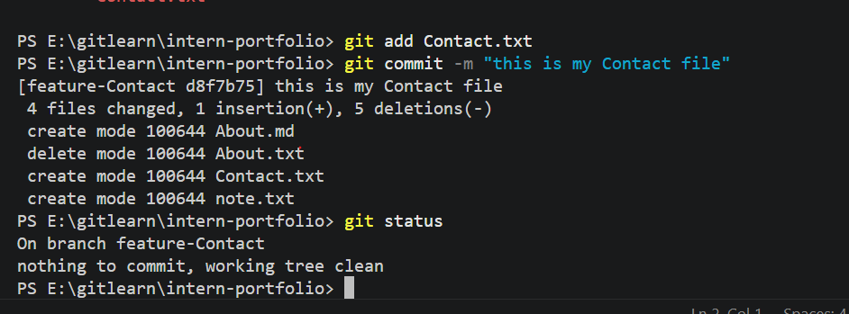
3. Commit and push this branch to GitHub.

4. On GitHub.com, open a Pull Request from feature-contact into main, with a clear title and description.
5. Merge the Pull Request from the GitHub interface.
